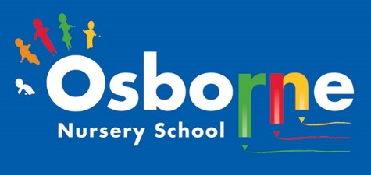
Osborne News
February 2026 
www. osbornenurseryschool.co.uk

Dates for your diary:
Thursdays: Stay and Play (under 2s) every Thursday morning – 9:45 – 11:15am at OSBORNE NURSERY SCHOOL.
WC 2nd Febuary – Parent/ carer progress meetings – make sure you have booked your appoitment with your key worker.
Monday 9th and Wednesday 11th February – Little Learners parent meetings
Monday February 16th– Friday February 20th – HALF TERM – nursery closed for all.
Wednesday 4th March – World Book Day celebrations
Monday 30th March – 10th April - Easter holiday – nursery closed
Please remember to telephone us on 0121 675 1123 if your child is too ill to be at nursery. Please keep us updated with any changes of address or phone numbers. We miss you when you are not here!

Nursery News:
Welcome to our February newsletter! This month brings lots of wonderful learning opportunities, and celebrations.
Well done to all of the new children that have started in Little Learners and Explorers during January. They have settled really well! Our lovely practitioners have worked hard to help your child feel safe and happy and given them a sense of belonging at our nursery.

Some children have moved up from Little Learners to Explorers – the visits before Christmas really helped their transition. Well done to you too!
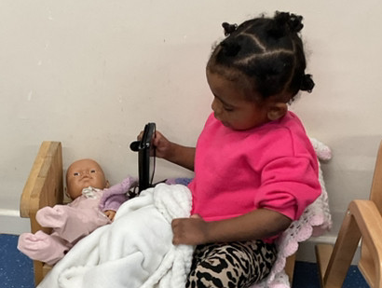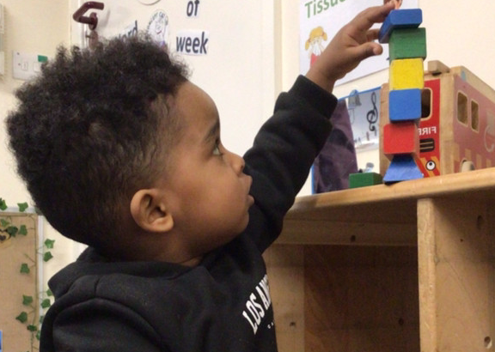
Remember to send in a bag, named with spare clothes, pants, socks and wipes. Look out for Forest School too!

Attendance is very important at Nursery. We like to see you for all of your sessions each week. We like families to aim for attendance to be between 95 and 100%. Look out for the Cool Kittens stickers!
Congratulations to CATERPILLARS AM 91%-and CIRCLES PM– 96% for the best attendance in Nursery in January 2025. FANTASTIC!! Well done to the parents and carers too.

Self help skills:
As part of your child’s learning journey, we practice self help skills. We encourage your child to be independent:
Taking off a coat
Putting a coat on
Toilet training
Drinking out of a cup
Using a knife and fork
Washing own hands
Any support at home with these skills would be fantastic!


This year we will be working towards reaccrediting out Rights Resecting Silver Award. You will have seen our posts about ‘ I have the right to a name’ and’ I have the right to play’
Ronnie Rabbit is helping the children understand their rights.

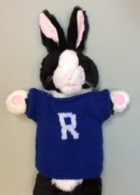

Rights Respecting Schools Award (RRSA)
Internet safety: Safer Internet Day takes place in February of each year to raise awareness of a safer and better internet for all, and especially for children and young people. Our children will be reading a story all about a penguin that learns how to stay safe when using the internet.
PLUG
Its ok to UNPLUG for a few hours – children need a break and should be encouraged to do something else. They could play with toys, visit family/ friends or run around outside. You’ll both bebfit if you ignore the messages on your phone whilst playing or talking with your child. ( You’ll save some elecrticty too!)

The Playhouse Theatre:
The Playhouse Theatre group came to visit our Explorers children. The children had a wonderful time. Juliet told the story of Jack and the Beanstalk – one of our favourites!
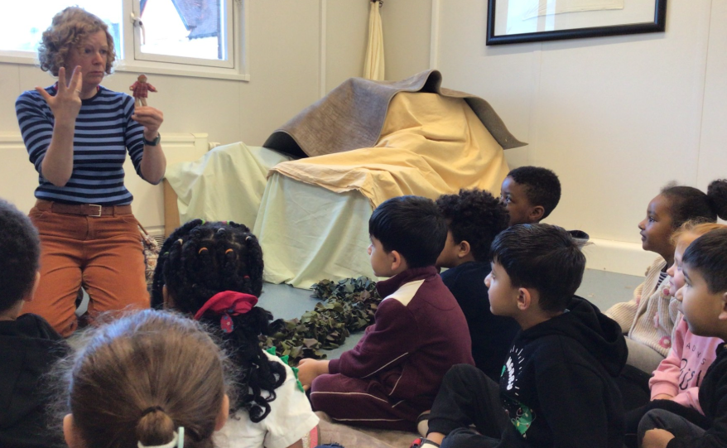

Please ask your child about the experience they had!

It is great to see the children bringing back their library books every Wednesday – we hope you are enjoying reading at home.
Recommended reading this month:
Traditional Tales
There are lots of versions of Goldilocks and the Three Bears . See if you can find the story in the library or online
Keep reading every day too – talk about the pictures and see if your child can retell the story.
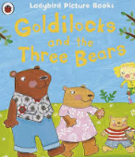

We would like to wish all of our families a very happy Luna New Year.
We will be learning about Luna New Year and the children will take part in different learning activities.
This year is ‘Year of the Horse’ and is all about energy, freedom and adventure.
There are lots of events on in Birmingham – details will be posted on Tapestry .

